Lab 8: Stages and Semi Structured Data

1. Activate Notebook

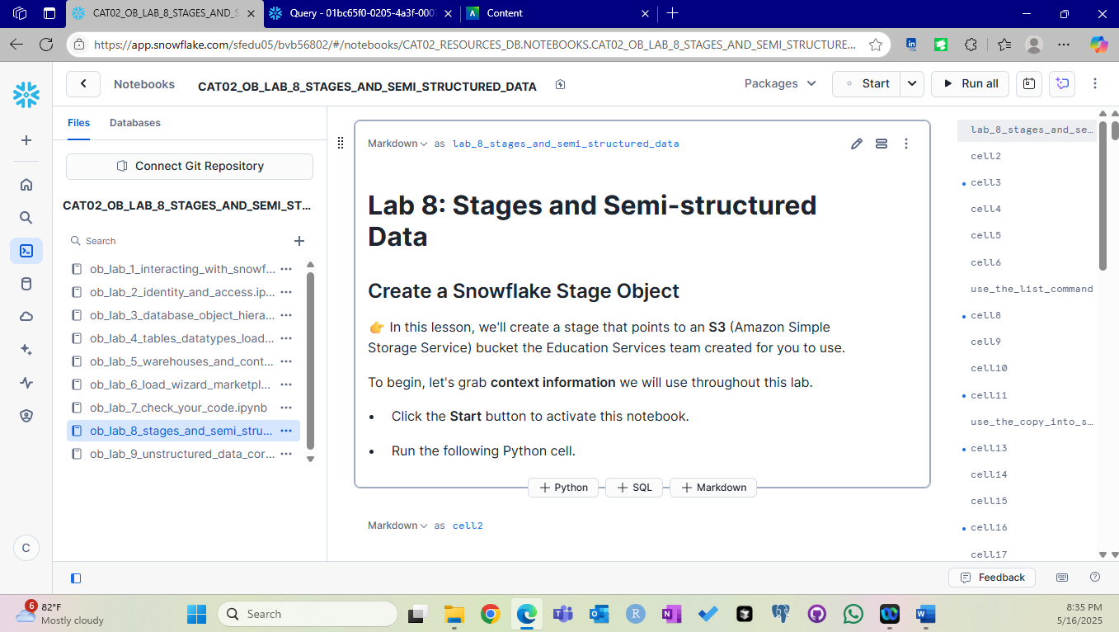

1. Stage Creation

1. USE list command

1. Check your work – Check 8

1. USE COPY INTO command

1. Check your work – Check 9

1. Challenge

1. Check your work – Check 10

1. Create a table with variant data type

1. Load JSON data

1. Query semi structured data

1. Create view

1. Check 11

1. Knowledge Check

1. End session

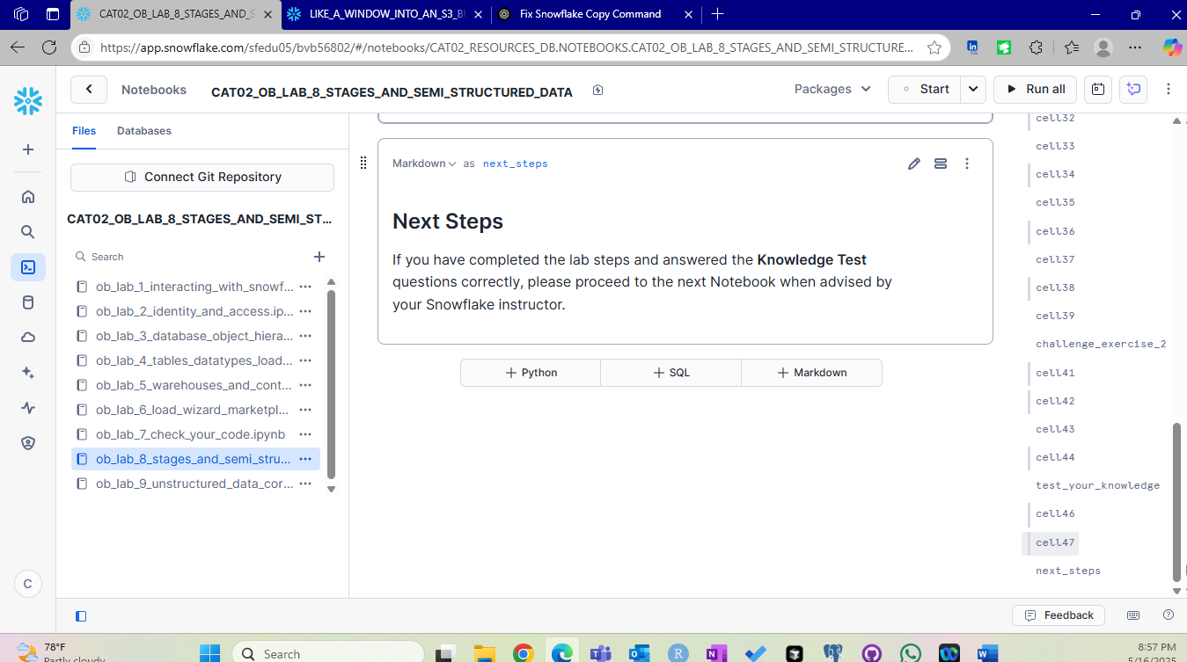

Summary :

In this lab, we create a stage which is our window to connect to an external source (S3, Azure , GCP). Snowflake standardized naming conventions by converting everything to UPPERCASE. We then use COPY INTO statement to load the data from S3 bucket into a table. When loading the file we can make file format settings such as file type, delimiter, header. Using the variant data type we parse the semi structured data (JSON in this case) . The variant function flattens the rows for easy referencing. We create a view to showcase semi structured data and end the lab session after performing knowledge checks.